**Policies and Permissions**

This section will guide you to:

* Implement policies and permissions on an S3 bucket

This lab has three subsections, namely:

3.18.1 Creating a bucket

3.18.2 Adding policies

3.18.3 Pushing the files to GitHub repositories

**Step 3.18.1:** Creating a bucket

* Create a new bucket in which we want to add policy with all default settings.

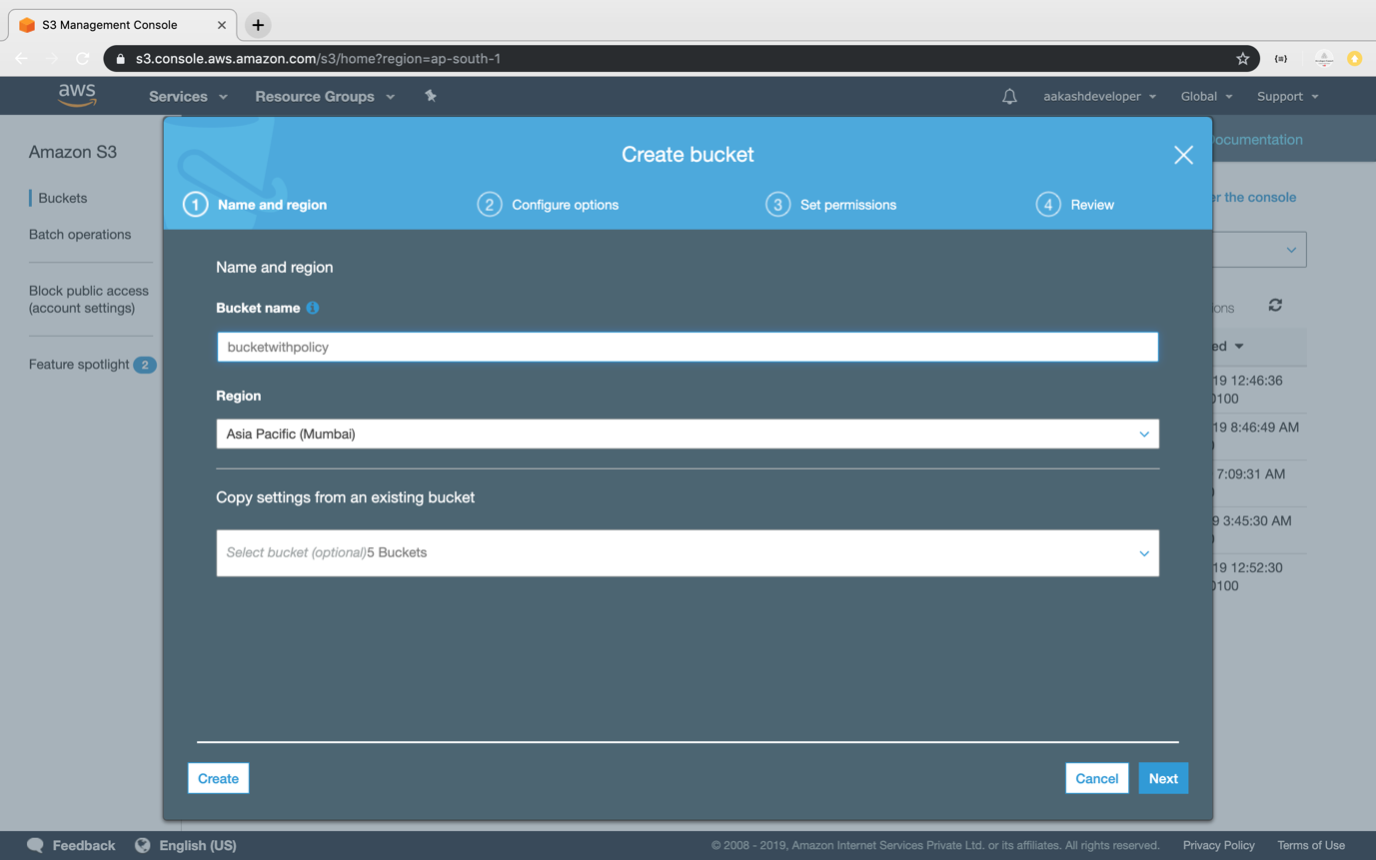

* Click on the *Permission* section.
* Go to *Bucket Policy*.
* It will open the console where you can add policy.

**Step 3.18.2:** Adding policies

* Click on the *Policy Generator*.

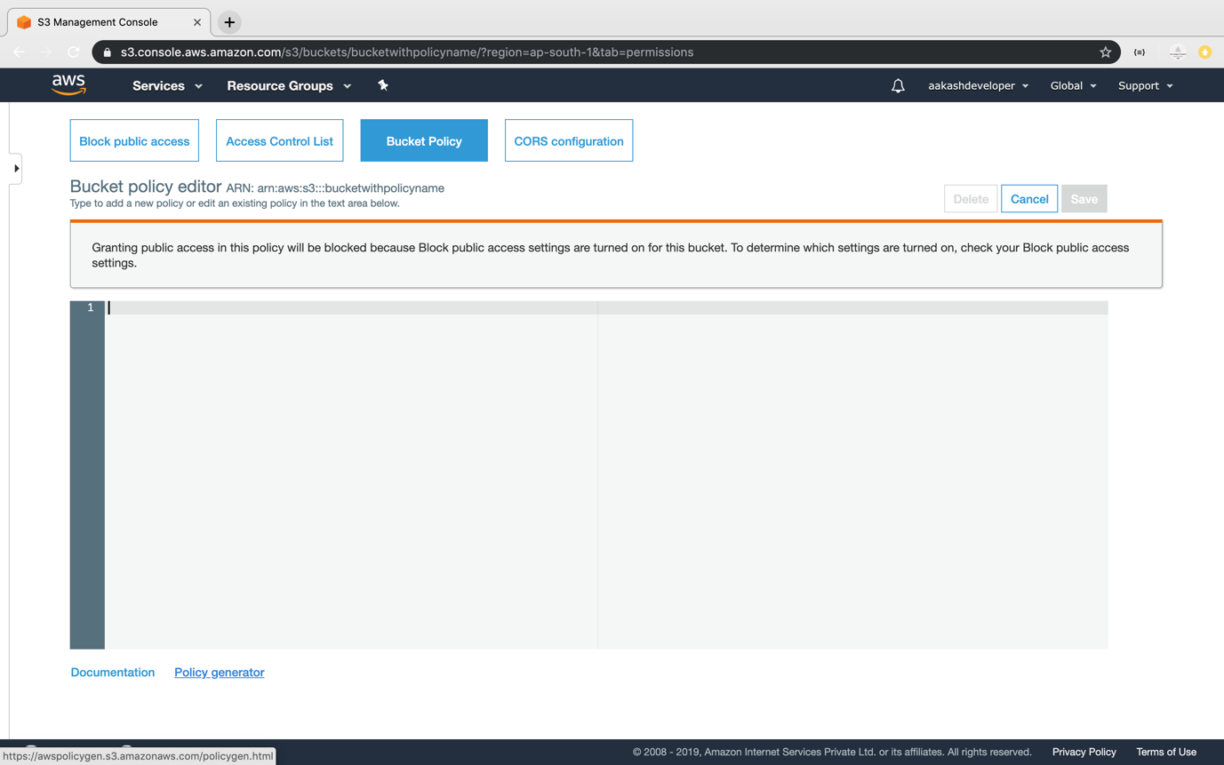

* Select the type of policy and services required.

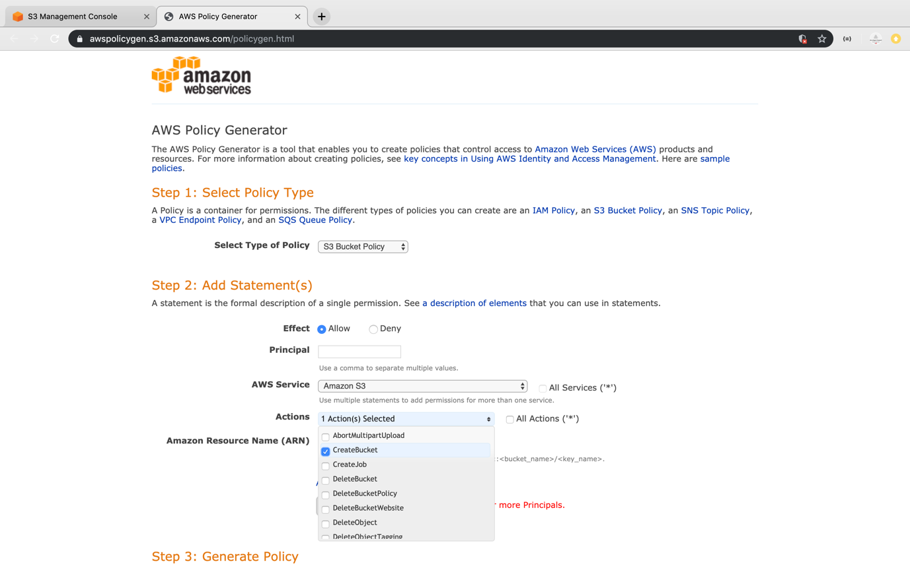

* Add ARN for S3 to add the policy.

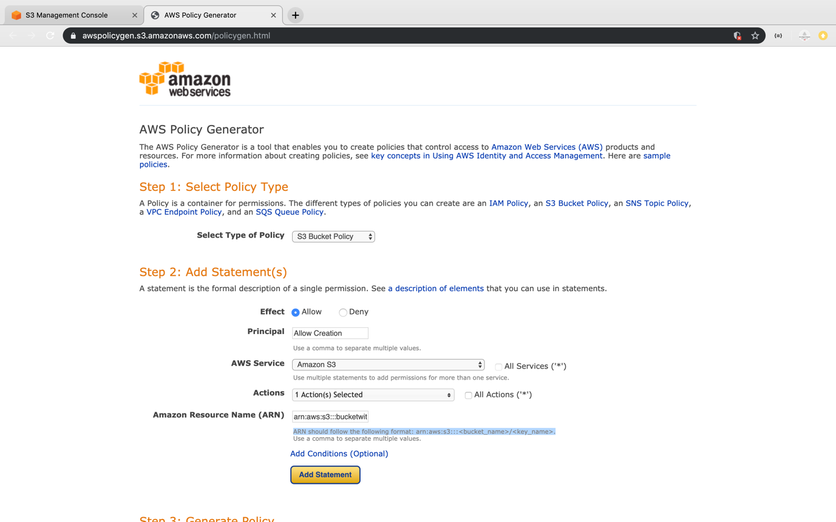

* Click on policy generator to create the JSON of the policy.

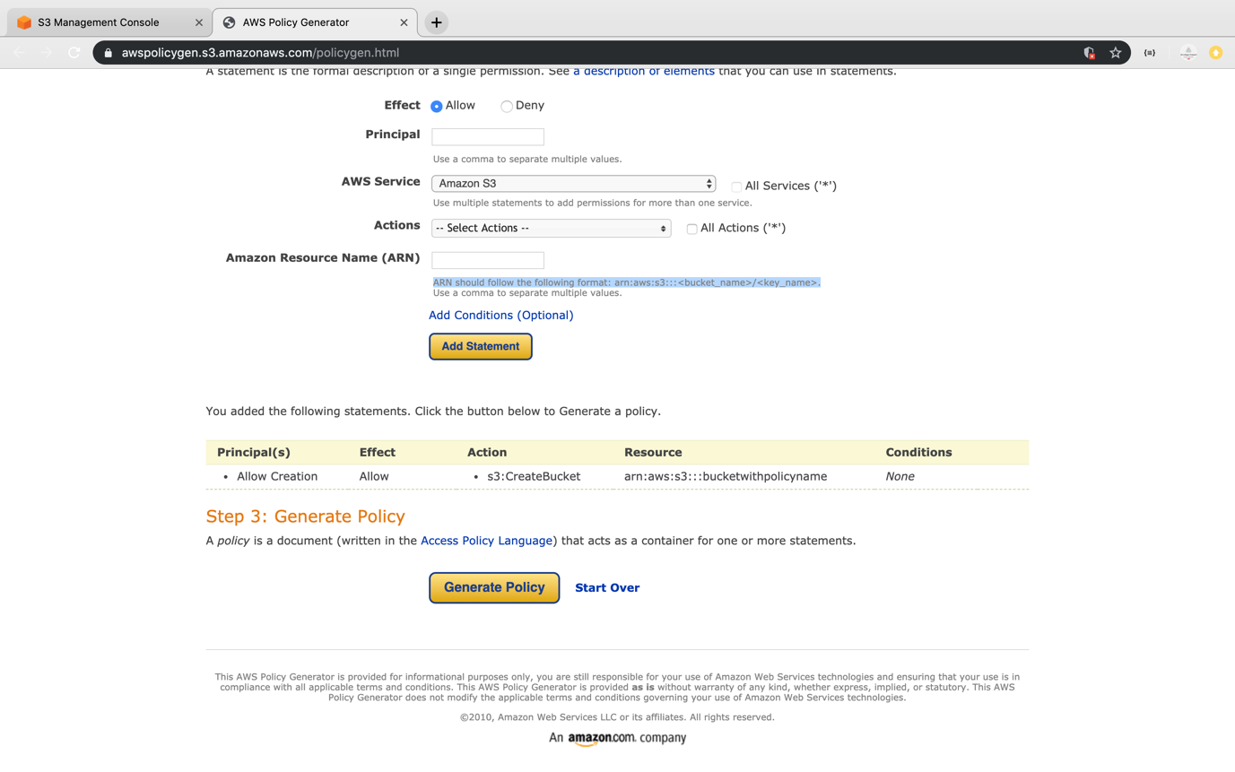

* Copy the generated JSON.

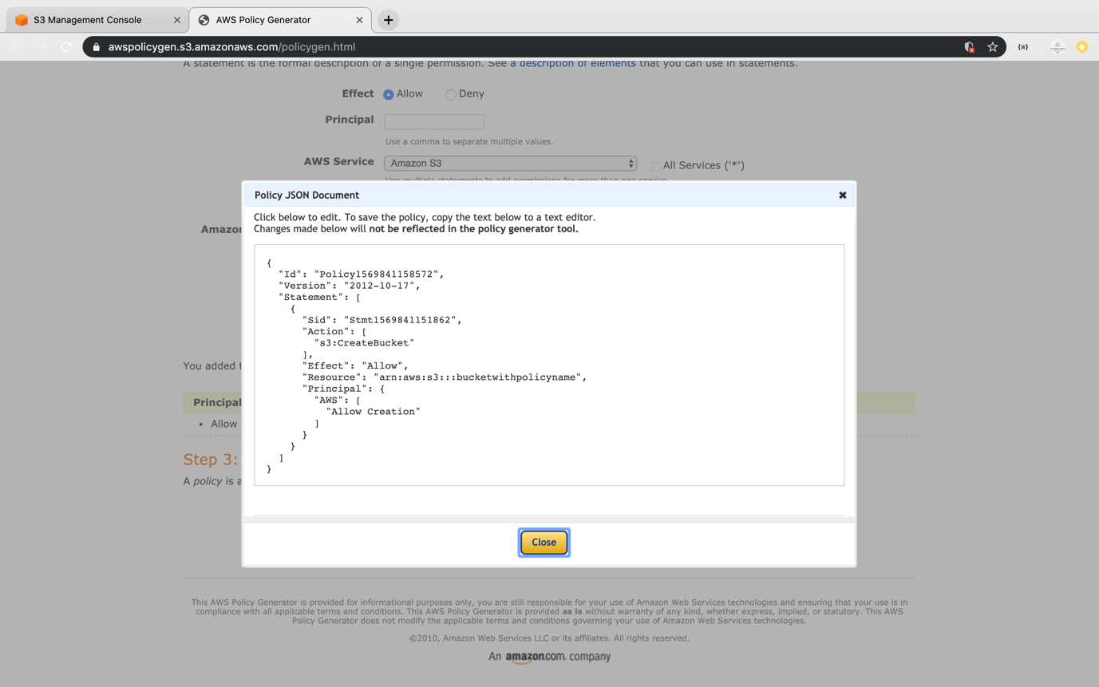

* Paste the JSON in the policy console of bucket and click on *Save*.

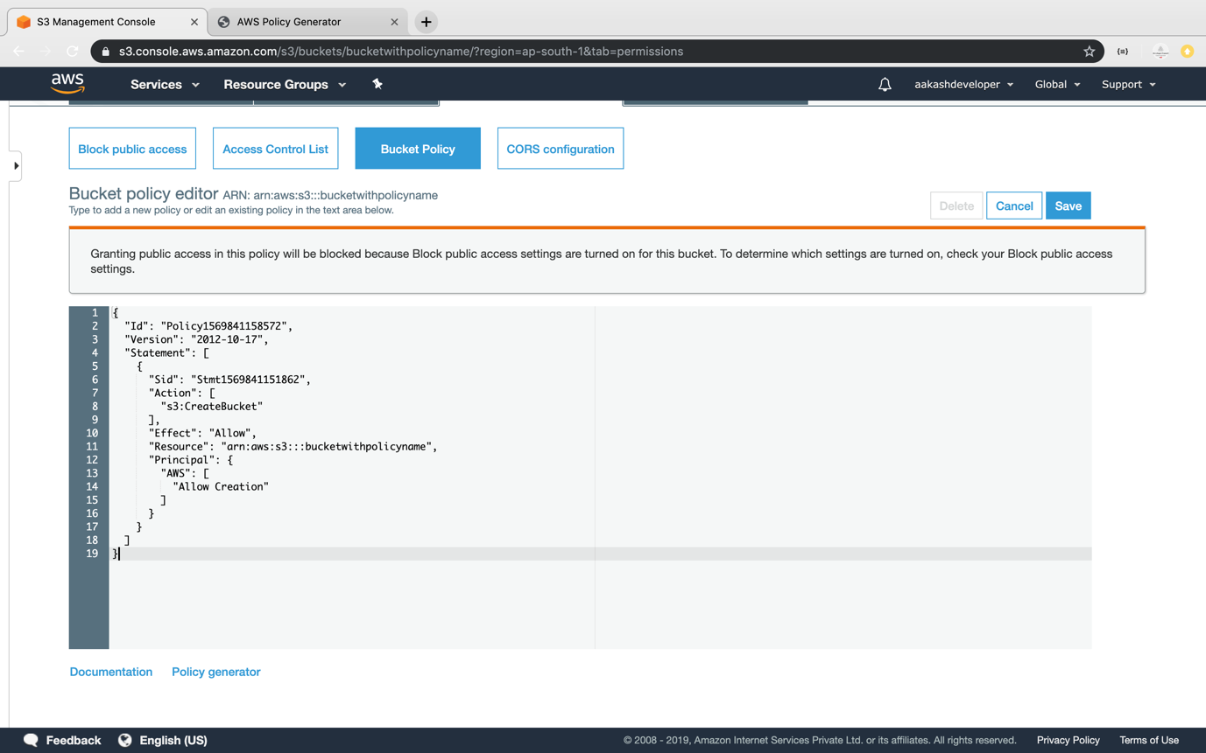

**Step 3.18.3:** Pushing the code to your GitHub repositories

* Open your command prompt and navigate to the folder where you have created your files.

**cd <folder path>**

* Initialize your repository using the following command:

**git init**

* Add all the files to your git repository using the following command:

**git add .**

* Commit the changes using the following command:

**git commit . -m “Changes have been committed.”**

* Push the files to the folder you initially created using the following command:

**git push -u origin master**